Embedded Android for cars:

O que é?

* Android Automotive is an actual Android-based operating system designed for vehicles, different from Android Auto.
* Android Automotive is much more tightly-integrated with the features of your car – depending on the set-up, it can even control various sensors and switches in the vehicle.
* Gives car OEMs more control over UI and what the system controls
* Full customization is important for adoption, because many automakers have made it clear that they want to own and control the core experience, which they consider an extension of the car brand itself.

Como funciona?

* It's not much different than the way Android works on phones, where UI elements and built-in apps differ from OEM to OEM, but all phones can generally run the same ecosystem of downloaded apps
* Expect implementations from different automakers to look and feel unique, with different design elements and display types.

Car Models where it is available: (at Google I/O 2017)

* Audi Q8
* Volvo V90 SUVs

A big part of Google's approach with Android in the car is to allow manufacturers to tailor the experience. For Audi, that means using Nokia's Here Maps in addition to Google Maps, and a design that's true to the Audi aesthetic.

For Volvo, the company can keep the four-tile screen layout that customers are familiar with, yet still rely on Android to run the vehicle's connected components.

Vantagens:

* They implemented the Android source code by reconfiguring it into a car OS, without involving Google
* This attempt, unfortunately, has failed because by the time the product reached the market (after a long development process), the version of Android launched was older and it cannot be updated
* Though the anticipation that Google will produce a Play Store for the car OS is still not been confirmed. But the latest OS promises the control for Heating, ventilation and air conditioning (HVAC) unit and radio as well.

Garage mode (Low power mode)

* The car parked in garage overnight can kick into this mode and download all the necessary updates while still connected to the internet.
* This will facilitate an updated and ready-to-go Operating system when the driver has to use the car.

Audi Q8 Sport concept interior powered by Android/AUDI AG~

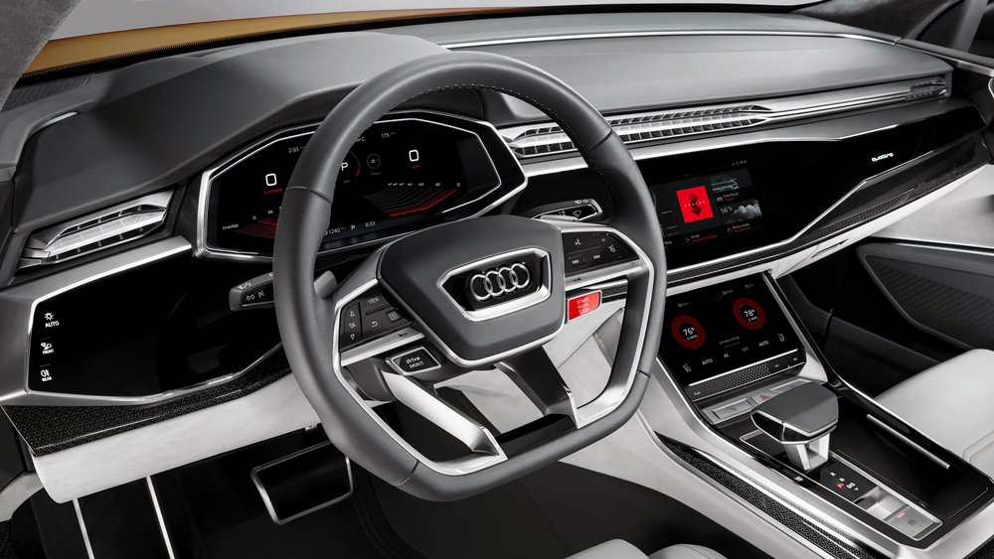

Volvo XC60 concept interior powered by Android/Volvo Car Group

